INTRODUCTION TO MICROPROCESSORS LABORATORY 1

In this laboratory,we have 3 switches.When we throw on switches what are odd numbers of them,the led runs.If they are not even,the led doesn’t run.

|  |  |  |  |
| --- | --- | --- | --- |
| PE2 | PE1 | PE0 | PE3 |
| **0** | **0** | **0** | **1** |
| **0** | **0** | **1** | **0** |
| **0** | **1** | **0** | **0** |
| **0** | **1** | **1** | **1** |
| **1** | **0** | **0** | **0** |
| **1** | **0** | **1** | **1** |
| **1** | **1** | **0** | **1** |
| **1** | **1** | **1** | **0** |

My truth table is:

According to my truth table,my code is :

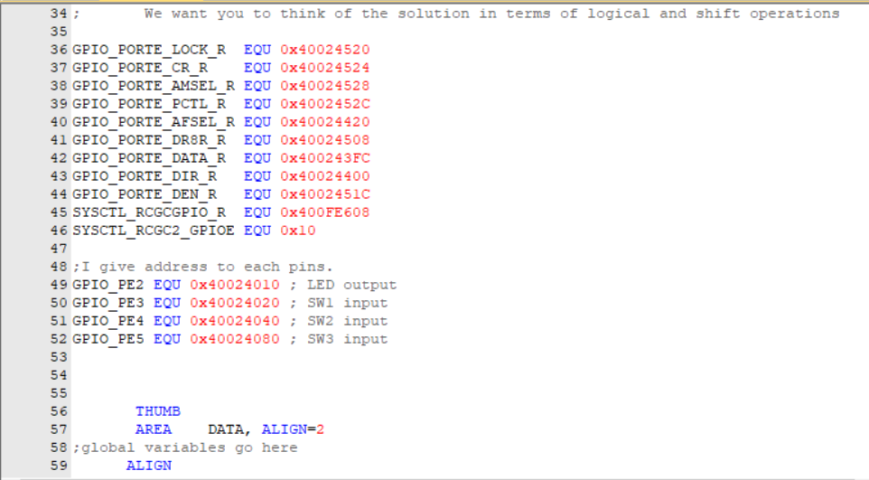

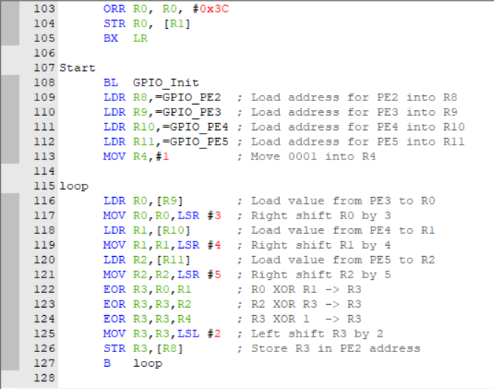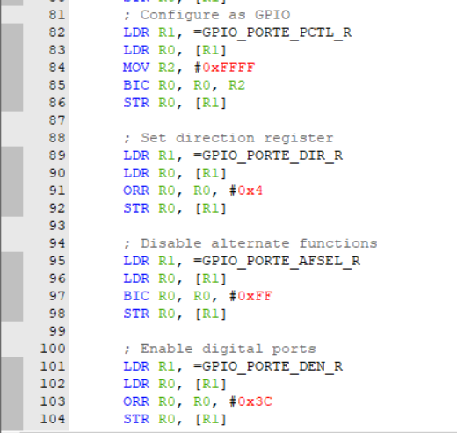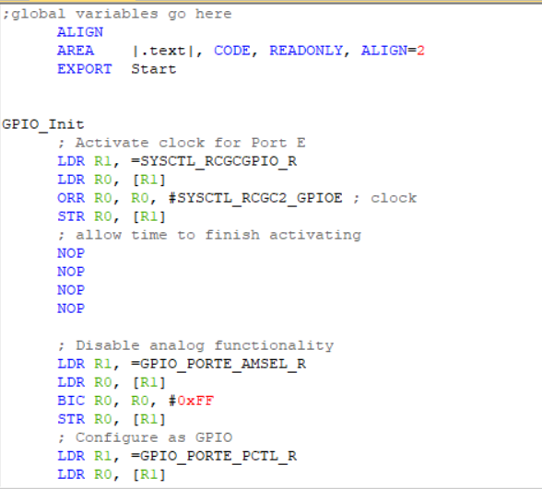

When I simulate it, if odd switches are throwed on,it looks like:

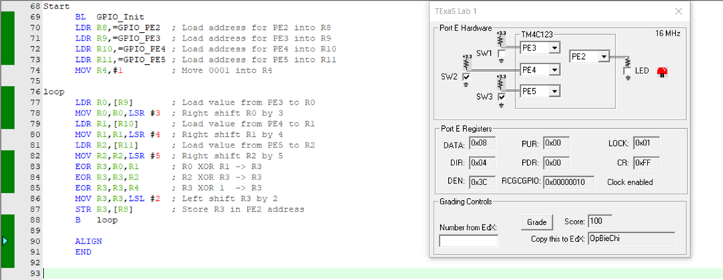

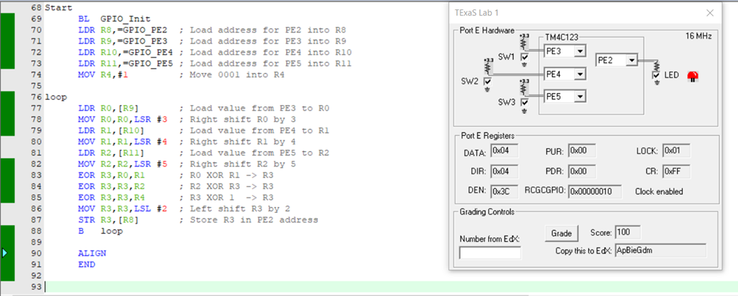If even switches are throwed on,it looks like: